Network Configuration Steps
Step 1: Interface IP Configuration
- Router0:
  - Gig0/0 (LAN): 192.168.0.1 | Subnet: 255.255.255.0
  - Gig0/1 (WAN): 192.168.1.1 | Subnet: 255.255.255.0
- Router1:
  - Gig0/0 (WAN): 192.168.1.2 | Subnet: 255.255.255.0
  - Gig0/1 (LAN): 192.168.2.1 | Subnet: 255.255.255.0
Step 2: PC Configuration
- PC0: IP 192.168.0.2 | Mask 255.255.255.0 | Gateway 192.168.0.1
- PC1: IP 192.168.0.3 | Mask 255.255.255.0 | Gateway 192.168.0.1
- PC2: IP 192.168.2.2 | Mask 255.255.255.0 | Gateway 192.168.2.1
- PC3: IP 192.168.2.3 | Mask 255.255.255.0 | Gateway 192.168.2.1
Step 3: Static Routing Configuration
- Router0 CLI Command:
ip route 192.168.2.0 255.255.255.0 192.168.1.2
- Router1 CLI Command:
ip route 192.168.0.0 255.255.255.0 192.168.1.1
Step 4: Verification
- Run ICMP ping traffic in the Simulation Panel from PC0 to PC2.
- Verify successful end-to-end packet delivery.

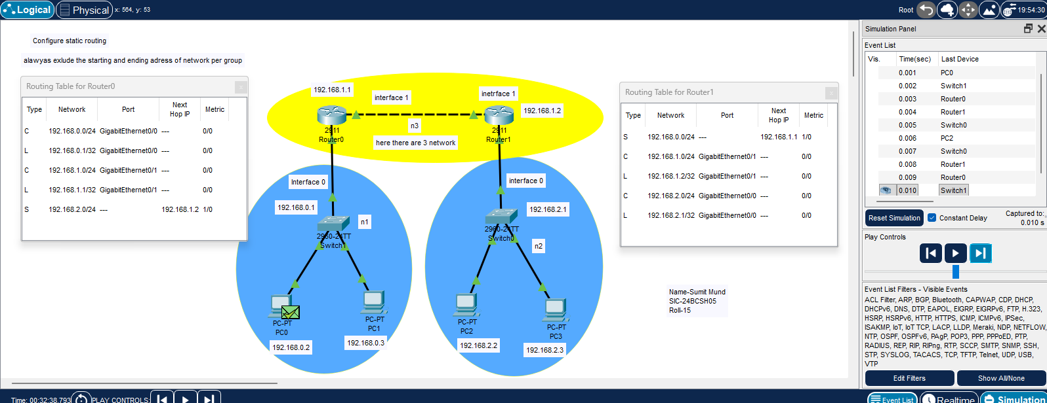

- With 4 router
Network Configuration Steps
Step 1: Network Topology Setup
- Add four routers (Router0, Router1, Router2, Router3) using standard serial or gigabit connections as displayed.
- Connect two switches to the respective local area networks.
- Connect end-user PCs (PC0, PC1, PC2, PC3) to their corresponding switches.
- Assign all interface IP addresses according to the topology labels (e.g., 192.168.0.1, 192.168.1.1, etc.).
Step 2: End-Device IP Configuration
- Set up PC0 with IP 192.168.0.2 and default gateway 192.168.0.1.
- Set up PC1 with IP 192.168.0.3 and default gateway 192.168.0.1.
- Set up PC2 with IP 192.168.2.2 and default gateway 192.168.2.1.
- Set up PC3 with IP 192.168.2.3 and default gateway 192.168.2.1.
Step 3: Static Routing Table Configuration
Configure static routes on each router to achieve complete network connectivity across all subnets:
- Router0 Static Routes:
  - Destination: 192.168.2.0/24 via Next Hop: 192.168.1.2
- Router1 Static Routes:
  - Destination: 192.168.0.0/24 via Next Hop: 192.168.4.1
- Router2 Static Routes:
  - Destination: 192.168.0.0/24 via Next Hop: 192.168.1.1
  - Destination: 192.168.2.0/24 via Next Hop: 192.168.3.2
- Router3 Static Routes:
  - Destination: 192.168.0.0/24 via Next Hop: 192.168.3.1
  - Destination: 192.168.2.0/24 via Next Hop: 192.168.4.2
Step 4: Connectivity Verification
- Enter Simulation Mode or use the Add Simple PDU tool.
- Send an ICMP echo request packet from source PC0 to destination PC2.
- Verify that the final status indicator displays Successful in the PDU list window.



